**STAR APPLICATION**

**A Project Report Submitted**

**In Partial Fulfilment of the Requirements**

**For the Degree of**

**MASTER OF COMPUTER APPLICATION**

**Submitted by**

**VEDANT MOHAN**

**(Roll No - 1900290149107)**

**Under the Supervision of**

**Mr. ANKIT VERMA**

**(Assistant Professor)**

**KIET Group of Institutions,**

**Delhi-NCR, Ghaziabad**

**Submitted to**

**DEPARTMENT OF COMPUTER APPLICTIONS**

**Affiliated to**

**DR. APJ ABDUL KALAM TECHNICAL UNIVERSITY**

**LUCKNOW**

**(Formerly Uttar Pradesh Technical University, Lucknow)**

**JULY,2021**

**DECLARATION**

I hereby declare that the work presented in this report entitled “**STAR APPLICATION**", was carried out by me. I have not submitted the matter embodied in this report for the award of any other degree or diploma of any other University or Institute.

I have given due credit to the original authors/sources for all the words, ideas, diagrams, graphics, computer programs, experiments, results, that are not my original contribution. I have used quotation marks to identify verbatim sentences and given credit to the original authors/sources.

I affirm that no portion of my work is plagiarized, and the experiments and results reported in the report are not manipulated. In the event of a complaint of plagiarism and the manipulation of the experiments and results, I shall be fully responsible and answerable.

**Name:** **VEDANT MOHAN**

**Roll. No.:** **1900290149107**

**Branch:** **MCA**



**Vedant Mohan**

**(Candidate Signature}**

**CERTIFICATE**

Certified that **Vedant Mohan (Roll No. 1900290149107)** have carried out the project work having “**Star Application**” for Master of Computer Applications from Dr. A.P.J. Abdul Kalam Technical University (AKTU**)** (formerly UPTU), Technical University, Lucknow under my supervision. The project report embodies original work, and studies are carried out by the student himself/herself and the contents of the project report do not form the basis for the award of any other degree to the candidate or to anybody else from this or any other University/Institution.

**Date:**

**Vedant Mohan**

**University Roll No. 1900290149107**

This is to certify that the above statement made by the candidate is correct to the best of my knowledge.

**Date:**

**Mr. Ankit Verma**

**Associate Professor**

**Department of Computer Applications**

**KIET Group of Institutions, Ghaziabad**

**Signature of Internal Examiner Signature of External Examiner**

**Dr. Ajay Shrivastava**

**Head, Department of Computer Applications**

**KIET Group of Institutions, Ghaziabad**

**ABSTRACT**

This application provide the user friendly interface , eassy to use without any registration . The user get the information and can also give the feedback. And the maintenance of this application is very eassy .

**•** The goal of this project is to display Horoscope to the user With the efficient and easy manner.

• This Android Application provide the real time Horoscope to the user with the notification update related to it.

• After reading or Listening the Horoscope the user can give the feedback also related to the Horscope.

• In this Android application we also use the Ad Mob , to generate some revenue .

• This application is implemented by using the Firebase (Real Time Data base , Cloud Notification , Ad Mob.

**ACKNOWLEDGEMENTS**

Success in life is never attained single handedly. My deepest gratitude goes to my thesis supervisor **Mr. Ankit Verma** for his guidance, help and encouragement throughout my project work . Their enlightening ideas, comments, and suggestions.Words are not enough to express my gratitude to **Dr. Ajay Kumar Srivastava**, Professor and Head, Department of Computer Applications, for his insightful comments and administrative help at various occasions .

Fortunately, I have many understanding friends,who have helped me a lot on many critical conditions.

Finally, my sincere thanks go to my family members and all those who have directly and indirectly provided me moral support and other kind of help. Without their support, completion of this work would not have been possible in time. They keep my life filled with enjoyment and happiness.

**VEDANT MOHAN**

**University Roll No, 1900290149107**

**TABLE OF CONTENT**

**Pages No.**

Declaration ii

Certificate iii

Abstract iv

Acknowledge v

Table of content vi

List of figures viii

**CHAPTER 1: INTRODUCTION**  9-13

* 1. Project Description 9
  2. Project Scope 11
  3. Hardware/software used in Project 12
  4. Project Schedule 13

1.4.1 Gannt chart

**CHAPTER 2: FEATURING AND IMAGES** 14-31

2.1 Introduction 14

2.2 Database 17

2.3 Cloud Notification 24

2.4 Ad mob 29

**CHAPTER 3: LITERATURE REVIEW** 32-39

* 1. Introduction 34
  2. Design and GUI 36
  3. Result 38
  4. Discussion 39
  5. Conclusion & Feature Scope 39

**CHAPTER 4: CODING** 42-77

**CHAPTER 5: DESIGN** 78-79

**CHAPTER 6: FEASIBILITY STUDY** 80-84

6.1Introduction 80

6.2 Main Aspects 82

6.2.1 Economical feasibility 82

6.2.2 Technical Feasibility 83

6.2.3 Operational Feasibility 83

6.3 Benefits 84

**CHAPTER 7: TESTING** 85-89

7.1 Introduction 85

7.2 Type of Testing 86

7.3 Level of Testing 88

7.4 Some Important Observation 89

**CHAPTER 8: CONCLUSION AND FUTURESCOPE** 90

Reference 91

**LIST OF FIGURES**

Figure 1.1 Gannt chart 13

Figure 2.1 ListView 15

Figure 2.2 output 15

Figure 2.3 Data 22

Figure 2.4 Rules 24

Figure 2.5 Some Screen 29

Figure 2.6 Notification 30

Figure 2.7 Admob Some Screen 34

Figure 3.1 Realtime data 39

Figure 3.2 Notofication 39

Figure 3.3 Database 40

Figure 3.4 Adds 41

Figure 5.1 30

Figure 5.2 30

# CHAPTER 1

# INTRODUCTION

* 1. **PROJECT DESCRIPTION**

The objective of this application is to show horoscope to the user of the application .“**Stars Application”** is an Advanced and Informative System helping the users to know the Horoscope or any interesting things . This System helps the Users to keep themselves up to date .The user is allowed to view the Horoscope and give their comments related to it . Admin will monitor the Realtime data and comments. The Front end used is Android Studio while backend as google Firebase Database. The user does not want to register into the system to use this application only they have to download the application from the play store or from the website . The latest Horoscope is shown first and so on, the user can also refresh it resulting the latest one shown first and current will be closed . The Look and feel of reading the Horoscope is exciting and amazing as the system provides swipe to move to the next or previous with transition effects.

**Design / GUI of Application :** The designing of this application is done in xml . using the linear layout all the children of the linear layout are stacked one after the another, so a vertical list will only have one children per row , no matter how wide they are, and a horizontal list will only one row high and listview .

**Database:** For this application we use Google firebase Realtime database this data base is very helpful Because it update the data at real time . This feature help in quickly date the data . The user of the application can also give the feed back in the form of comment and these comments are monitor by the administrator of the data base .

**Cloud Messaging / Notification:** Firebase Cloud Messaging  is a part of the firebase platform for mobile development . With Firebase Cloud Messaging, you can send notifications to all of your installed app users, or a subset of them, without setting up a server . You can remotely push a notification to a single device or multiple devices .

**Ad mob:** Ads are an effective and easy way to earn revenue from your apps. Google Ad Mob is a smart monetization platform for apps that helps you to maximize revenue from ads and in-app purchases. We here using cutting-edge technologies and advanced

tools to customize features in your application for meeting your needs. Our team of experts has mastery over technical skills to bring satisfactory experience to all your customers.

* 1. **PROJECT SCOPE**

The following documentation is a project the “**Star Application** “. It will predict he horoscope of the user this application does not require any type registration Process (as other application do, they require the registration first). It is easy to use and operate.

* + - It is very user friendly.
    - Errors are almost impossible as it requires less human interaction.
    - Accuracy in work.
    - Easy & fast retrieval of information.
    - Access to any information individually.
    - Work becomes very speedy.
    - Easy to update information
    - Easy availability.

**1.3 HARDWARE / SOFTWARE USED IN PROJECT**

* + 1. **Technologies / Software Requirements**
* Operating System: Windows
* Programming language: Java
* Front-End: Android
* Back-End: Google Firebase

**1.3.2 Hardware requirement / Hardware Used**

* Processor – i3
* Hard Disk – 120 GB
* Memory – 4GB RAM
* Android Phone with KitKat and higher

**1.4: PROJECT SCHEDULE**

The objective of software project planning is to provide a framework that enables the manager to make reasonable estimates of resources, costs and schedule. These estimates are made within a limited time frame at the beginning of a software project and should be updated regularly as the project progresses. In addition, estimates should attempt to define “best case” and “worst case” scenarios so that project outcomes can be bounded.

The first activity in software project planning is the determination of software scope. Function and performance allocated to software during system engineering should be assessed to establish a project scope that is ambiguous and understandable at Presidency and technical levels. Software scope describes function, performance constraints, interfaces and reliability.

**1.4.1 Gantt Chart**

When creating a project schedule, the planner begins with a set of tasks (the work breakdown structure). If automated tools are used, the work breakdown is input as a task network. Effort, duration and start dates are input are each task network. As a consequence of this input, a timeline chart also called a Gantt chart is generated. A timeline chart is developed for entire project.

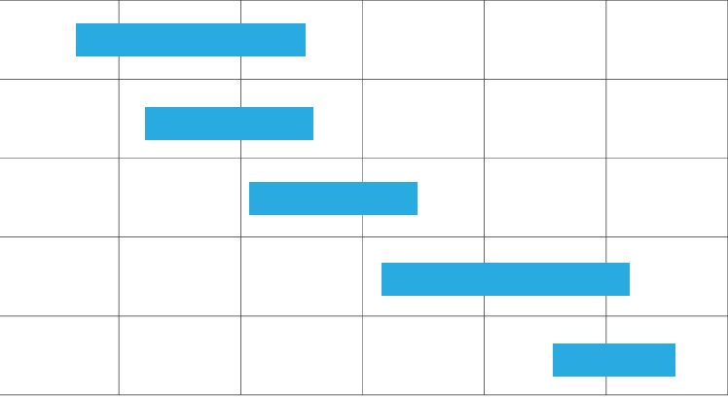

Deploy

Testing

Planning and

Analysis

Design

Coding

July

June

May

Apr

Task

Figure 1.1 Gannt Chart

**CHAPTER 2**

**FEATURING AND IMAGES**

**2.1 INTRODUCTION**

The cryptography is finished in Java language and therefore the style part (GUI) is created in XML language.

List of scrollable things are often displayed in automaton victimization ListView. It helps you to displaying the info within the variety of a scrollable list. Users will then choose any list item by clicking thereon. ListView is default scrollable thus we have a tendency to don't ought to use scroll read or anything with ListView.

ListView is wide utilized in automaton applications. a really common example of ListView is your phone contact book, wherever you have got an inventory of your contacts displayed during a ListView and if you click thereon then user info is displayed.

**2.1.1: Adapter:** To fill the info during a ListView we have a tendency to merely use adapters. List things are mechanically inserted to an inventory victimization AN Adapter that pulls the content from a supply like AN array list, array or info.

Android ListView may be a read that teams many things and show them in vertical scrollable list. The list things are mechanically inserted to the list victimization AN Adapter that pulls content from a supply like AN array or info.

An adapter truly bridges between UI parts and therefore the knowledge supply that fill knowledge into UI part. Adapter holds the info and send the info to adapter read, the read will take the info from adapter read and shows the info on completely different views like as spinner, list view, grid read etc

**2.1.2: Array Adapter:** Whenever you have got an inventory of single things that is backed by AN array, you'll use Array Adapter. for example, list of phone contacts, countries or names.

Important Note: By default, Array Adapter expects a Layout with one Text View , If you would like to use a lot of advanced views means that a lot of customization in list things, please avoid Array Adapter and use custom adapters.

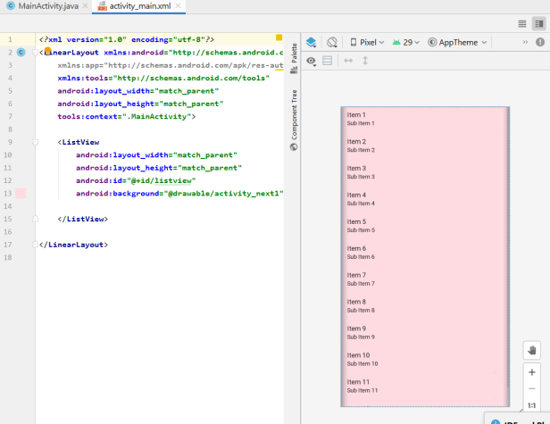

Figure 2.1 ListView

**Below is Array Adapter code:**

Array Adapter adapter = newArrayAdapter<String>(this,R.layout.ListView,R.id.textView,StringArray.

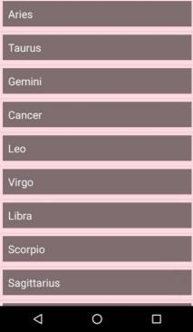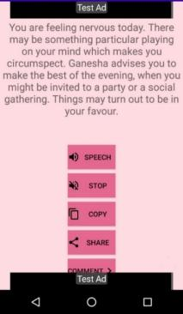

Figure 2.2 Output

**2.1.3: Android Scroll View (Vertical)**

The automaton. widget. Scroll View category provides the practicality of scroll read. Scroll View is employed to scroll the kid components of palette within Scroll View. automaton supports vertical scroll see default scroll read. Vertical Scroll View scrolls components vertically.  
Android uses HorizontalScrollView for horizontal ScrollView.Let's implement straightforward example of vertical Scroll View.

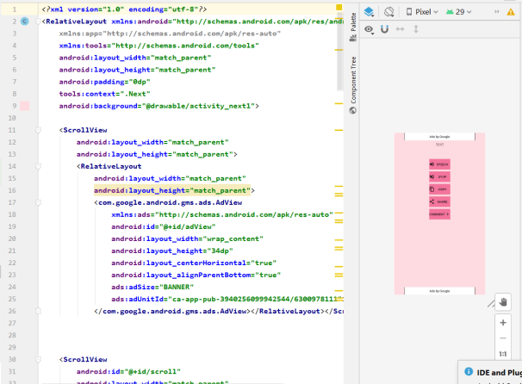

Figure 2.3 Button

**2.2 DATABASE**

**2.2.1: Firebase**

Build powerful apps. Spin up your backend while not managing servers. Effortlessly scale to support countless users with base databases, machine learning infrastructure, hosting and storage solutions, and Cloud Functions.

**2.2.2: Release & Monitor**

Improve app quality in less time with less effort. alter testing, triaging, and troubleshooting. rigorously roll out options and monitor adoption. Pinpoint, prioritize, and fix stability and performance problems early.

**Step 1:** Create a base project. Before you'll be able to add base to your humanoid app, you wish to make a base project to attach to your humanoid app. Visit perceive base comes to find out a lot of regarding base comes

**Step 2:** Register your app with base

To use base in your humanoid app, you wish to register your app along with your base project. Registering your app is usually referred to as "adding" your app to your project.

1: move to the base console.

2: within the centre of the project summary page, click the humanoid icon (plat android) or Add app to launch the setup work flow.

3: Enter your app's package name within the humanoid package name field.

4: (Optional) Enter alternative app information: App nickname and correct sign language certificate SHA-00

5 Click Register app.

**Step 3:** Add a base configuration file

1: Add the base humanoid configuration file to your app:

Click transfer google-services. Son to get your base humanoid config file (google-services. Son). Move your config file into the module (app-level) directory of your app.

2: To alter base product in your app, add the google-services plugin to your Gradle files. In your root-level (project-level) Gradle file (build. gridle), add rules to incorporate the Google Services Gradle plugin. ensure you have got Google's virtuoso repository, as well.

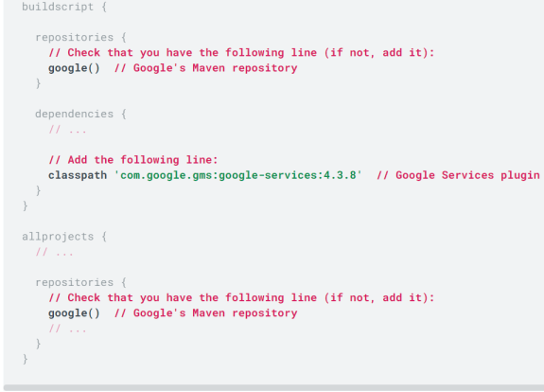

In your module (app-level) Gradle file (usually app/build.gradle), apply the Google Services Gradle plugin:

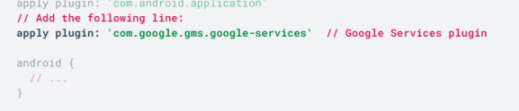

**Step 4:** Add base of operations SDKs to your app

Using the base of operations automaton BoM, declare the dependencies for the base of operations product that you simply wish to use in your app. Declare them in your module (app-level) Gradle file (usually app/build.gradle).

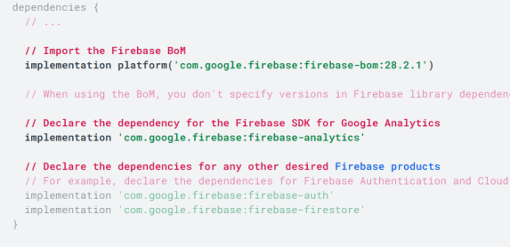

**2.2.3: Firebase Realtime information**

Store and adjust knowledge with our NoSQL cloud information. knowledge is synced across all purchasers in Realtime, and remains out there once your app goes offline.

The base Realtime information may be a cloud-hosted information. knowledge is kept as JSON and synchronised in Realtime to each connected shopper. once you build cross-platform apps with our iOS, Android, and JavaScript SDKs, all of your purchasers share one Realtime information instance and mechanically receive updates with the latest knowledge.

**2.2.4: Key capabilities**

Realtime Instead of typical communications protocol requests, the base Realtime information uses knowledge synchronization—every time knowledge changes, any connected device receives that update inside milliseconds. give cooperative and immersive experiences doltishly concerning networking code.

Offline base apps stay responsive even once offline as a result of the Firebase Realtime information SDK persists your knowledge to disk. Once property is re-established, the shopper device receives any changes it lost, synchronizing it with this server state.

Accessible from shopper Devices The base Realtime information is accessed directly from a mobile device or internet browser; there’s no want for associate degree application server. Security and knowledge validation are out there through the base Realtime information Security Rules, expression-based rules that are dead once knowledge is scan or written.

Scale across multiple databases with base Realtime information on the Blaze evaluation set up, you'll support your app's knowledge wants at scale by cacophonous your knowledge across multiple information instances within the same base project. contour authentication with base Authentication on your project and attest users across your information instances. management access to the information in every information with custom base Realtime information Rules for every information instance.

**How will it work**

The base Realtime information enables you to build wealthy, cooperative applications by permitting secure access to the information directly from client-side code. knowledge is persisted regionally, and even whereas offline, Realtime events still hearth, giving the top user a responsive expertise. once the device regains affiliation, the Realtime information synchronizes the native knowledge changes with the remote updates that occurred whereas the shopper was offline, merging any conflicts mechanically.

The Realtime information provides a versatile, expression-based rules language, referred to as base Realtime information Security Rules, to outline however your knowledge ought to be structured and once knowledge is scan from or written to. once integrated with base Authentication, developers will outline UN agency has access to what knowledge, and the way they'll access it.

The Realtime information may be a NoSQL information and per se has totally different optimizations and practicality compared to a electronic information service. The Realtime information API is meant to solely permit operations which will be dead quickly. this allows you to make an excellent Realtime expertise which will serve ample users while not compromising on responsiveness. owing to this, it's vital to have faith in however users have to be compelled to access your knowledge and so structure it consequently.

**Implementation path**

Integrate the base Realtime information SDKs Quickly embrace purchasers via Gradle, Cocoa Pods, or a script embrace.

• Create Realtime information References Reference your JSON knowledge, like "users/user:1234/ phone number" to line knowledge or purchase knowledge changes.

• Set knowledge and Listen for Changes Use these references to put in writing knowledge or purchase changes.

• Enable Offline Persistence permit knowledge to be written to the device's native disk therefore it is out there whereas offline.

• Secure your knowledge Use base Realtime information Security Rules to secure your knowledge.

**Connect your App to base**

**Create a information**

1: Navigate to the Realtime information section of the base console. you will be prompted to pick associate degree existing base project. Follow the information creation advancement.

2: choose a beginning mode for your base Security Rules:

**Test mode**

Good for obtaining started with the mobile and internet shopper libraries, however permits anyone to scan and write your knowledge. once testing, check that to review the perceive base Realtime information Rules section.

To get started with the net, iOS, or automaton SDK, choose take a look at mode.

**Locked mode**

Denies all reads and writes from mobile and internet purchasers. Your documented application servers will still access your information.

3: select a section for the information. counting on your alternative of region, the information namespace is going to be of the shape.firebaseio.com or.firebasedatabase.app. For additional info, see choose locations for your project.

4: Click Done.

When you modify Realtime information, it additionally allows the API within the Cloud API Manager.

Add the Realtime information SDK to your app

Using the base automaton BoM, declare the dependency for the Realtime information automaton library in your module (app-level) Gradle file (usually app/build.gradle).

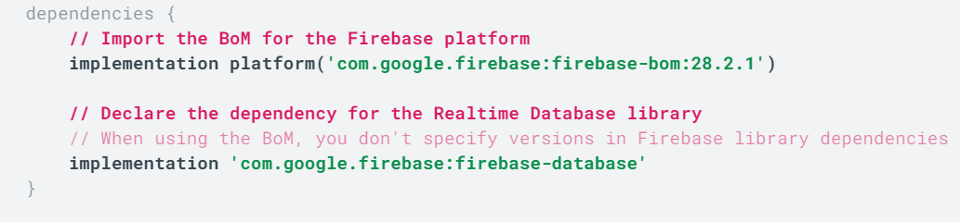

Realtime Database is Firebase's original database. It's an efficient, low-latency solution for mobile apps that require synced states across clients in realtime.

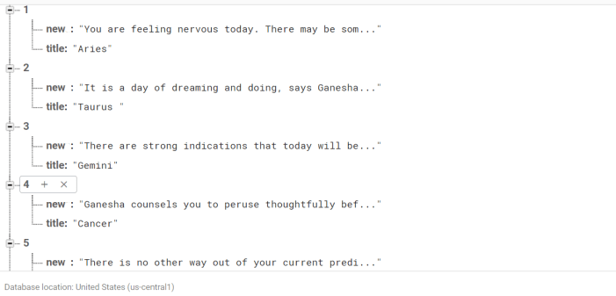

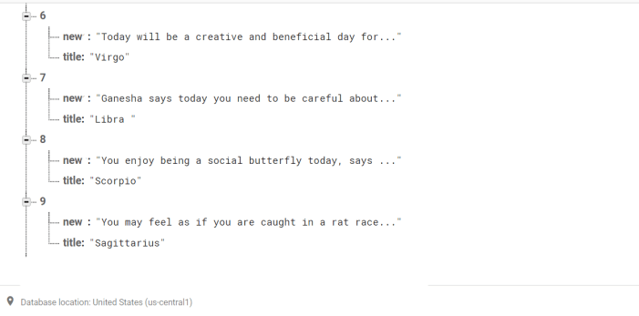

Figure 2.3 Data

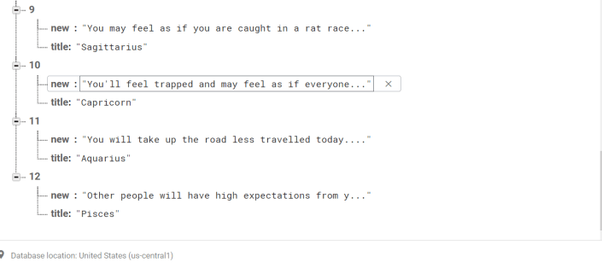

**Configure Realtime information Rules**  
The Realtime information provides a declarative rules language that enables you to outline however your information ought to be structured, however it ought to be indexed, and once your information is scan from and written to.  
  
**Write to your information**  
Retrieve Associate in Nursing instance of your information mistreatment get Instance () and reference the placement you wish to put in writing to.

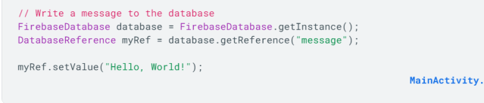

You can save a range of data types to the database this way, including Java objects. When you save an object the responses from any getters will be saved as children of this location.

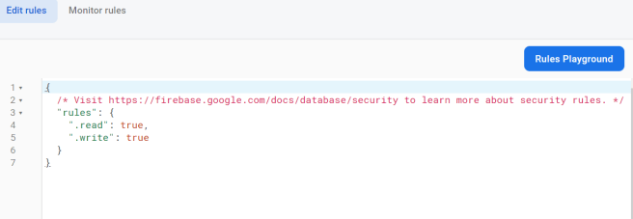

Figure 2.4 Rules

**Read from your database**

To make your app data update in Realtime, you should add a ValueEventListener to the reference you just created.

The onDataChange () method in this class is triggered once when the listener is attached and again every time the data changes, including the children.

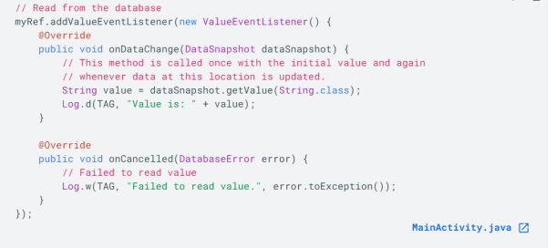

**2.3: CLOUD NOTIFICATION**   
  
**2.3.1: Set up a base of operations Cloud electronic communication consumer app on automaton**

To write your base of operations Cloud electronic communication automaton consumer app, use the Firebase Messaging API and automaton Studio one.4 or higher with Gradle. The directions during this page assume that you simply have completed the steps for adding base of operations to your automaton project.  
FCM shoppers need devices running automaton four.1 or higher that even have the Google Play Store app put in, or Associate in Nursing imitator running automaton four.1 with Google arthropod genus. Note that you simply aren't restricted to deploying your automaton apps through Google Play Store.

**2.3.2: Add a base of operations configuration file**

1: Add the base of operations automaton configuration file to your app:  
Click transfer google-services. Son to get your base of operations automaton config file (google-services.Son).  
Move your config file into the module (app-level) directory of your app.  
What does one got to fathom this config file?  
  
2: To change base of operations merchandise in your app, add the google-services plugin to your Gradle files.  
In your root-level (project-level) Gradle file (build. gridle), add rules to incorporate the Google Services Gradle plugin. certify you have got Google's star repository, as well.

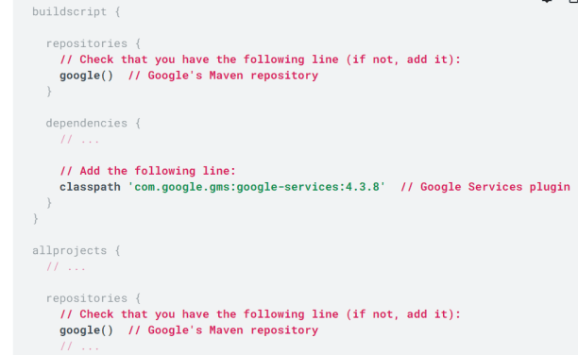

In your module (app-level) Gradle file (usually app/build.gradle), apply the Google Services Gradle plugin:

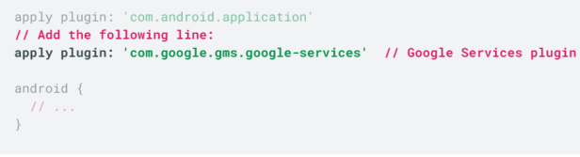

**2.3.3: Add base of operations SDKs to your app**

1 : victimisation the base of operations automaton BoM, declare the dependency for the base of operations Cloud electronic communication automaton library in your module (app-level) Gradle file (usually app/build.gradle).For Associate in Nursing best expertise with base of operations Cloud electronic communication, we tend to suggest enabling Google Analytics in your base of operations project and adding the base of operations SDK for Google Analytics to your app.  
  
2 : correct your app to make sure that each one dependencies have the mandatory versions . obtaining a build failure regarding invoke-custom support and enabling desugaring? Here's the way to fix it.

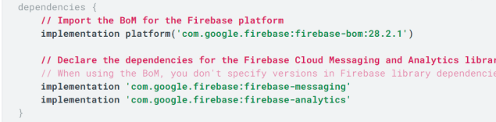

Edit your app manifest

Add the subsequent to your app's manifest:

A service that extends FirebaseMessagingService. this can be needed if you wish to try to to any message handling on the far side receiving notifications on apps within the background. To receive notifications in foregrounded apps, to receive information payload, to send upstream messages, and so on, you need to extend this service.

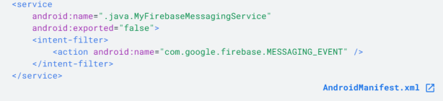

(Optional) at intervals the appliance part, data parts to line a default notification icon and colour. automaton uses these values whenever incoming messages don't expressly set icon or colour.'

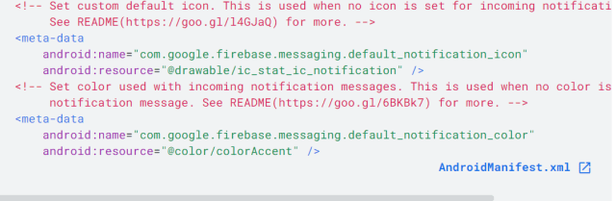

(Optional) From automaton eight.0 (API level 26) and better, notification channels area unit supported and suggested. FCM provides a default notification channel with basic settings. If you favour to make and use your own default channel, set default_notification_channel_id to the ID of your notification channel object as shown; FCM can use this worth whenever incoming messages don't expressly set a notification channel. to find out additional, see Manage notification channels.

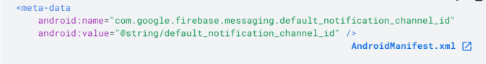

Access the device registration token

On initial start-up of your app, the FCM SDK generates a registration token for the consumer app instance. If you wish to focus on single devices or produce device teams, you will need to access this token by extending FirebaseMessagingService and dominant onNewToken.  
This section describes the way to retrieve the token and the way to observe changes to the token. as a result of the token may be revolved once initial start-up, you're powerfully suggested to retrieve the most recent updated registration token.

The registration token might modification when:  
  
• The app is improved on a replacement device  
• The user uninstalls/reinstall the app  
• The user clears app information.  
When you got to retrieve the present token, decision FirebaseMessaging.getInstance(). getToken ():

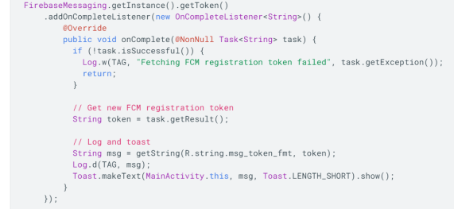

After the client app is set up, you are ready to start sending downstream messages with the Notifications composer. This functionality is demonstrated in the QuickStart sample, which you can download, run, and review.

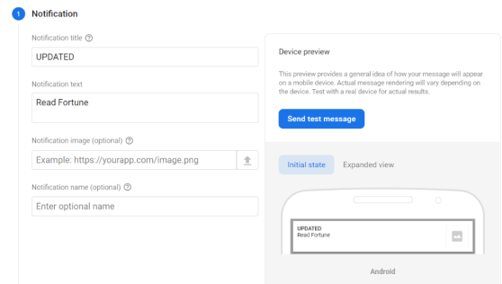

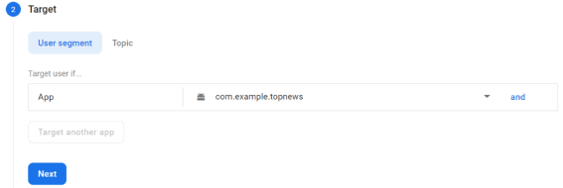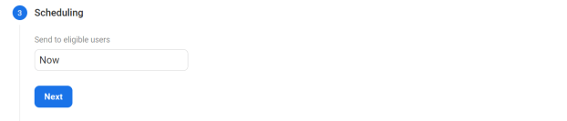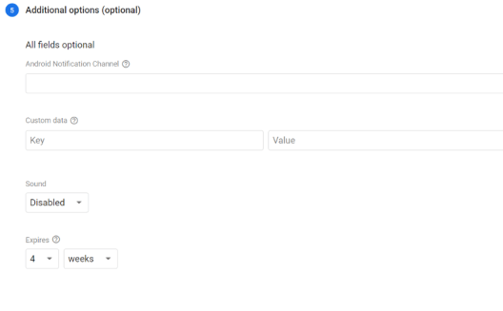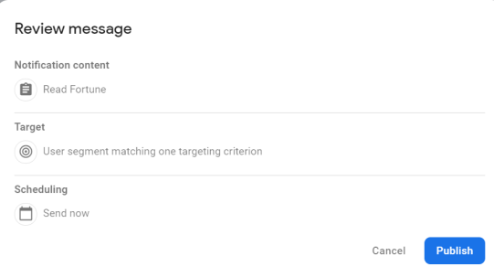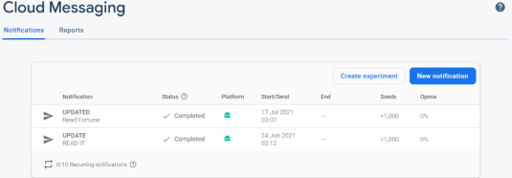

Figure 2.5 Some Screen

**Output on the android Application**



Figure 2.6 Notification

**2.4 ADMOB**

**Get started with Ad Mob in your golem project**

**Step 1:** originated your app in your Ad Mob account

Register your app as associate degree Ad Mob app.

Sign into or register for associate degree Ad Mob account.

Register your app with Ad Mob. This step creates associate degree Ad Mob app with a singular Ad Mob App ID that you're going to would like later during this guide.

You'll be asked to feature the Mobile Ads SDK to your app. realize elaborate directions for this task later during this guide.

Link your Ad Mob app to your base app.

This step is nonmandatory however powerfully suggested. Learn additional concerning the advantages of facultative user metrics and linking your Ad Mob app to base.

Complete the subsequent 2 steps within the Apps dashboard of your Ad Mob account:

Enable User Metrics to permit Ad Mob to method and show curated analytics information in your Ad Mob account. it is also a needed setting for you to link your Ad Mob app to base.

Link your Ad Mob app to your existing base project and base app.

Make sure that you simply enter a similar package name as you entered for your base app. realize your base app's package name within the Your apps card of your settings > Project settings.

**Step 2**: Add your Ad Mob App ID to your AndroidManifest.xml file

Add your Ad Mob App ID to your app's AndroidManifest.xml file by adding the tag as shown below.

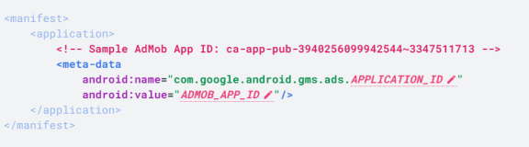

**Step 3:** Add and initialize the Mobile Ads SDK

Add the dependency for the Google Mobile Ads SDK to your app's module (app-level) build. gridle file:

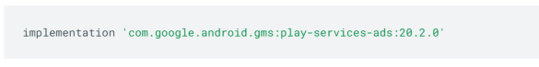

Before loading ads, call the MobileAds.initialize() method.

This call initializes the SDK and calls back a completion listener once initialization is complete (or after a 30-second timeout). Call this method only once and as early as possible, ideally at app launch.

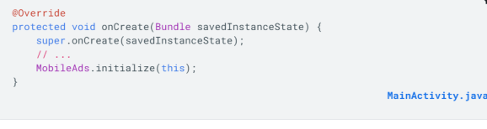

**Step 4:** read user metrics and analytics information

After its data formatting, the Mobile Ads SDK mechanically starts work analytics events and user properties from your app. you'll be able to read this information while not adding any further code to your app or implementing any ads. Here's wherever you'll be able to see this analytics data:

In the User metrics card of your Ad Mob account (Home or Apps dashboard), you'll be able to read curated user metrics derived from the collected analytics information, like average session length, ARPU, and retention.

In the Analytics dashboard of the base console, you'll be able to read aggregative statistics and summaries of key metrics. If you add the base SDK for Google Analytics, you'll be able to conjointly mark conversions for ad campaigns and build custom audiences within the base console.

Note that to raised represent ARPU and ARPPU metrics, you may need to incorporate information from associate degree analytics custom event known as ecommerce purchase within the revenue calculation for these metrics (learn how).

**Step 5:** (Optional) Use additional options of Google Analytics and base Take advantage of additional opportunities and options to boost app substantiation and user engagement:

Add and use the base SDK for Google Analytics.

Implement custom event work in your app.

Mark conversions for custom ad campaigns.

Include ecommerce purchase event information within the revenue calculation for ARPU and ARPPU metrics.

Use alternative base product in your app

After you add the base SDK for Google Analytics, use alternative base product to optimize ads in your app.

Remote Config allows you to alter the behaviour associate degreed look of your app while not business an app update, at no cost, for unlimited daily active users.

A/B Testing provides you the ability to check changes to your app’s UI, features, or engagement campaigns to be told if they create a bearing on your key metrics (like revenue and retention) before rolling the changes out wide.

Predictions applies machine learning to your analytics information to make dynamic user segments supported your users' foreseen behaviour. These predictions area unit out there to use in alternative base product.

**Step 6:** opt for an advert format to implement in your app

Ad Mob offers variety of various ad formats; therefore, you'll be able to opt for the format that most closely fits the user expertise of your app. Click a button for an advert format to look at elaborate implementation directions within the Ad Mob documentation.

**Banner**

Rectangular ads that seem at the highest or bottom of the device screen

Banner ads remain screen whereas user’s area unit interacting with the app, and may refresh mechanically once a definite amount of your time. If you are new mobile advertising, they seem to be a great spot to begin.

**Interstitial**

Full-screen ads that cowl the interface of associate degree app till closed by the user

Interstitial ads area unit best used at natural pauses within the flow of associate degree app's execution, like between levels of a game or simply once a task is completed.

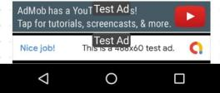

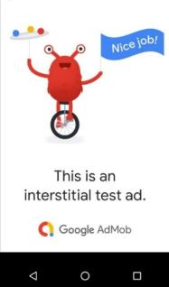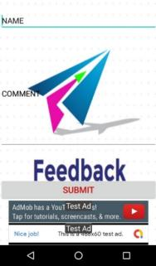

Figure 2.7 Admob Some Screen

**CHAPTER 3**

**LITERATURE REVIEW**

**ABSTRACT**

The goal of this project is to display Horoscope to the end user with the efficient and easy manner. This Android Application provide the real time data update to the user with the cloud messaging / notification update related to it.

During the development of the software the main concern is to improve the code quality and productivity & second concern is the software is free from crash. When software bugs occur finishing bug localization timely and accurately is an important guarantee for software quality.

The computing application requires a large-scale real-time data ingestion, analysis, and optimization. Real-time task scheduling. The data is transferred widely to the user in real time.

There are many data in this world that related each other so we need a system to do the data process.

Adopting Open-Source Software for commercial use as well as in the development also the most popular smartphone platforms are Android.

Smartphones and other connected devices rely on data services, such as Web Services (WS) Google Cloud Messaging (GCM) and Firebase Cloud Messaging (FCM).

**KEYWORDS**

* Web Services
* Google Cloud Messaging
* Firebase Cloud Messaging
* Firebase Real time Database
* Security in cloud
* Cloud security challenges
* Android Permission Security
* Network Security
* Cloud computing
* Real Time
* Bug Report

**3.1 INTRODUCTION**

During the software development one of the main concerns of Software Engineering is to improvement the code quality and productivity. The code documentations play a very important role in the software quality assurance and software development during the production **[1][2].**

Software crash is a serious form of the software failure, which often occurs during the software development and maintenance process. when the software crashes the stack trace reported generate, information about crashes. Thus, we recommend such a feature selection method to pre-process the crash instances before constructing classification models to predict the crash fault residence.

The software has been used widely in all aspect of our social life, the quality requirements of the software are getting higher and higher. When software bugs occur finishing bug localization timely and accurately is an important guarantee for software quality**.[3][4].**

Smart applications are Social computing applications. the results which are received by the end users or the performance that they experience is affected by the other users using the same application. this computing application requires a large-scale real-time data ingestion, analysis, and optimization. We call such applications a social computing application**.[5]**

Real-time task scheduling. We implement our proposed hierarchical scheduling on a realistic platform whose runtime overhead is shown to be acceptable. the data os transferred widely to the user in real time **[6]**

Individuals and companies in the past few decades have increasingly adopting Open-Source Software for commercial use, and in the development also. A very large portion of the modern application are built upon the open source **[7].**

Clone and Own (CaO) is a widespread approach to generate new software products from existing software products by adding small changes. **[8][9].**

The usage of smartphone has increased exponentially in the recent years. the most popular smartphone platforms are Android and iOS, along with the computational power they handle a wide array of applications attracts millions of users worldwide**.[10][11][12][13]**

There are many data in this world that related each other so we need a system to do the data process**.[14]**

Smartphones and other connected devices rely on data services, such as Web Services (WS), Google Cloud Messaging (GCM) and Firebase Cloud Messaging (FCM), to share the information they collect or use **[15]**

The objective of this application is to show horoscope to the end user. “**Stars Application** “is an Advanced and Informative System helping the users to know the Horoscope or any interesting things. This System helps the Users to keep themselves up to date. The user is allowed to view the Horoscope without any kind of registration and give their comments related to it. Admin will monitor the Horoscope data base and comments. The Front end is made Android Studio while backend as google Firebase Database. The user does not want to register into the system to use this application only they have to download the application from the play store or from the website. The latest Horoscope is shown first and so on, the user can also refresh it resulting the latest one shown first and current will be closed. The Look and feel of reading the Horoscope is exciting and amazing as the system provides swipe to move to the next or previous with transition effects.

**3.2 DESIGN AND GUI**

In this we define the project structure, feature, criteria for success the main objective is to create the desired project. our system in based on cloud.

The graphical user interface is one of the most important factors by which the user can easily access the application. An eassy and effective GUI is good for both user as well as developer.

The implementation of the system is done by the help android studio and google firebase3, by the help of Java language we built the application. With the help of admin panel we can access Realtime database , cloud notification , google Ad Mob .

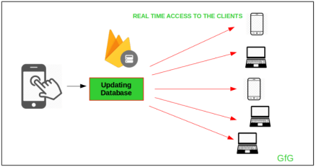

Figure 3.1

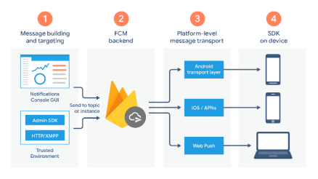

Figure3.2

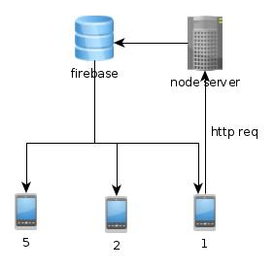

Figure3.3

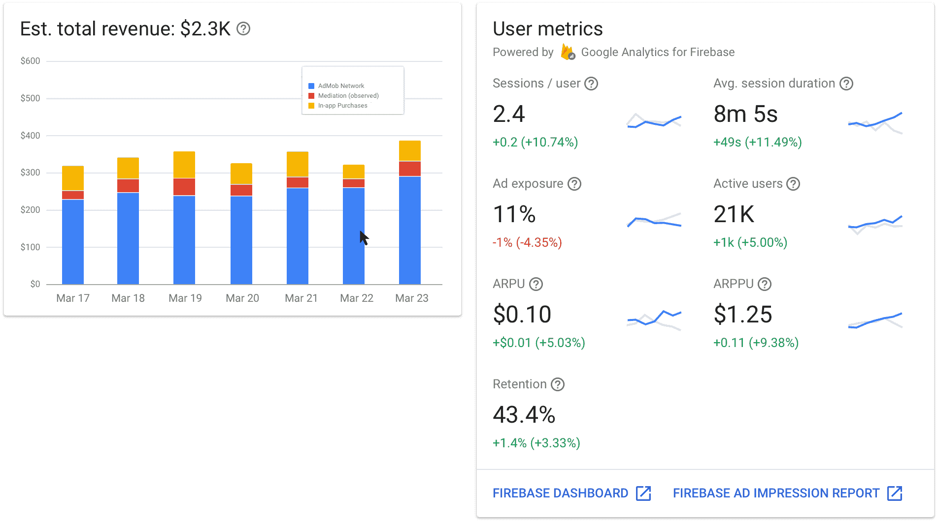

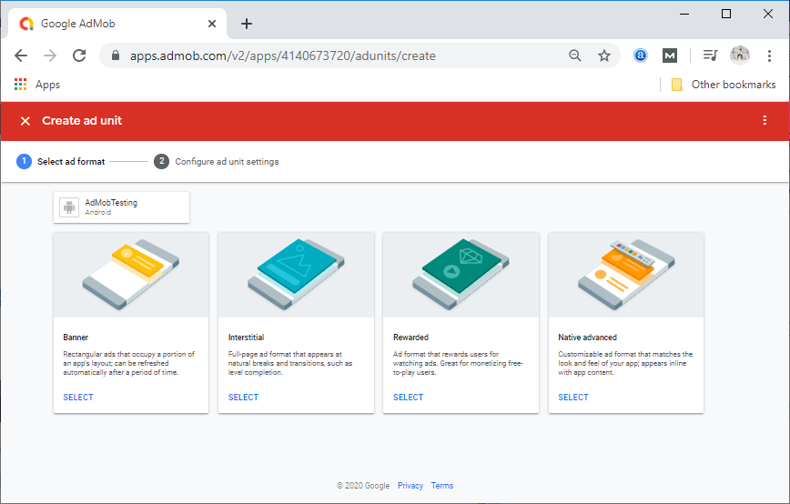

Figure3.4

**3.3 RESULT**

We have come on a result that our system working fine in each case. It is user friendly as well as efficient to use. we have done different things to verify the performance.

**Testing Test Scenarios**

1.Check if the page load time is within the acceptable range.

2.Check the page load on slow connections.

3.Check the response time for any action under a lighr, normal , moderate, and heavy load conditions.

4.Check the performance of database store procedure and triggers.

5.Check for load testing of the application.

6.Check the database execution time.

7.Check for the stress testing of the application.

**TEST CASE RESULT**

|  |  |  |
| --- | --- | --- |
| **Testcase#** | **Description** | **Result** |
| TC#1 | Loading Data | Passed |
| TC#2 | Connection | Passed |
| TC#3 | Content | Passed |
| TC#4 | First Display | Passed |
| TC#5 | Second Display | Passed |
| TC#6 | Third Display | Passed |
| TC#7 | Notification | Passed |

**3.4 DISCUSSION**

System was utterly done when was punctually coded. every modules of the project were checked to confirm they're totally useful units.[4] This was done by checking every unit to offer assurance that it functions PRN which it performed precisely as outlined. The success of every individual gave North American country move to carryout testing properly [9].

The outlined system was valid by the employing a series of knowledge that was utterly stuffed by representatives admin. The users United Nations agency have used the system and provides suggestion per the requirement. This was done to the assess if the system met their individual desires and necessities. it had been additionally noticing that it's straightforward to access the info still as obtainable once required. With the pliability of the cloud google base it's quite helpful and higher management system.[14][15]

**3.5 CONCLUSION & FEATURE SCOPE**

A system means that a ton of expertise. I learned a ton of issue throughout the development of this project. This project has additionally sharpened my idea cloud computing google base.

To make our system additional economical and user friendly. I will be able to add base Predictions and applies machine learning to the current application. These predictions square measure mechanically obtainable to the top user.

**REFERENCES**

[1] da Silva Junior, L. L. N., Kohwalter, T. C., de Carvalho, A. P., & Murta, L. G. P. (2021). Sequential coding patterns: How to use them effectively in code recommendation. Information and Software Technology, 106690.

[2] Liu, S., Guo, Z., Li, Y., Lu, H., Chen, L., Xu, L., ... & Xu, B. (2021). Prioritizing code documentation effort: Can we do it simpler but better?. Information and Software Technology, 106686.

[3] Vogel, T., Tran, C., & Grunske, L. (2021). A comprehensive empirical evaluation of generating test suites for mobile applications with diversity. Information and Software Technology, 130, 106436.

[4] Li, Z., Jiang, Z., Chen, X., Cao, K., & Gu, Q. (2021). Laprob: A Label propagation-Based software bug localization method. Information and Software Technology, 130, 106410.

[5] García-Valls, M., Dubey, A., & Botti, V. (2018). Introducing the new paradigm of social dispersed computing: Applications, technologies and challenges. Journal of Systems Architecture, 91, 83-102.

[6] Yang, T., Deng, Q., & Sun, L. (2019). Building real-time parallel task systems on multi-cores: A hierarchical scheduling approach. Journal of Systems Architecture, 92, 1-11.

[7] McClean, K., Greer, D., & Jurek-Loughry, A. (2020). Social network analysis of open source software: A review and categorisation. Information and Software Technology, 106442.

[8] Echeverría, J., Pérez, F., Panach, J. I., & Cetina, C. (2021). An empirical study of performance using Clone & Own and Software Product Lines in an industrial context. Information and Software Technology, 130, 106444.

[9] Van Antwerp, M. (2010). Evolution of Open Source Software Networks. In OSS 2010 Doctoral Consortium, Collocated with the 6th International Conference on Open Source Systems, OSS 2010 (pp. 25-39).

[10] Garg, S., & Baliyan, N. (2021). Comparative analysis of Android and iOS from security viewpoint. Computer Science Review, 40, 100372.

[11] Steven Salerno, Ameya Sanzgiri , Shambhu Upadhyaya . Exploration of Attacks on Current Generation Smartphones . Procedia Computer Science , 2011 , Pages 546-553

12] Jason K. MacDuffie , Patricia A. Morreale . Comparing Android App Permissions . DUXU 2016 , pp57-64

[13] Kumar, R., & Goyal, R. (2019). On cloud security requirements, threats, vulnerabilities and countermeasures: A survey. Computer Science Review, 33, 1-48.

[14] Ohyver, M., Moniaga, J. V., Sungkawa, I., Subagyo, B. E., & Chandra, I. A. (2019). The comparison firebase realtime database and MySQL database performance using wilcoxon signed-rank test. Procedia Computer Science, 157, 396-405.

[15] Albertengo, G., Debele, F. G., Hassan, W., & Stramandino, D. (2020). On the performance of web services, google cloud messaging and firebase cloud messaging. Digital Communications and Networks, 6(1), 31-37.

**CHAPTER 4**

**CODING**

This chapter contains some codes of the project.The goal of the coding is to translate the design of the system into code in a given programming language. For a given design, the aim of this phase is to implement the design in the best possible manner. The coding phase affects both testing and maintenance profoundly.

**Some Codes are as Written below :**

**MainActivity.java**

package com.example.stars;

import androidx.annotation.NonNull;

import androidx.appcompat.app.AppCompatActivity;

import androidx.core.net.ConnectivityManagerCompat;

import android.content.Context;

import android.content.Intent;

import android.net.ConnectivityManager;

import android.net.Network;

import android.net.NetworkInfo;

import android.os.Bundle;

import android.view.View;

import android.widget.AdapterView;

import android.widget.ArrayAdapter;

import android.widget.ListView;

import android.widget.Toast;

import com.google.android.gms.ads.AdRequest;

import com.google.android.gms.ads.InterstitialAd;

import com.google.firebase.database.DataSnapshot;

import com.google.firebase.database.DatabaseError;

import com.google.firebase.database.DatabaseReference;

import com.google.firebase.database.FirebaseDatabase;

import com.google.firebase.database.ValueEventListener;

import java.util.ArrayList;

import java.util.List;

import java.util.concurrent.Executor;

import java.util.concurrent.ScheduledExecutorService;

public class MainActivity extends AppCompatActivity {

ListView listView;

DatabaseReference databaseReference;

List<String> title_list,news_list,new_list;

ArrayAdapter<String> adapter;

mynews mynews;

@Override

protected void onCreate(Bundle savedInstanceState) {

super.onCreate(savedInstanceState);

setContentView(R.layout.activity_main);

checkConnection();

listView=findViewById(R.id.listview);

databaseReference= FirebaseDatabase.getInstance().getReference("News");

mynews= new mynews();

title_list=new ArrayList<>();

news_list=new ArrayList<>();

adapter=new ArrayAdapter<>(this,R.layout.item,R.id.item_txt,title_list);

databaseReference.addValueEventListener(new ValueEventListener() {

@Override

public void onDataChange(@NonNull DataSnapshot dataSnapshot) {

title_list.clear();

news_list.clear();

for(DataSnapshot ds : dataSnapshot.getChildren()){

mynews =ds.getValue(mynews.class);

if (mynews != null) {

title_list.add(mynews.getTitle());

}

if (mynews != null) {

news_list.add(mynews.getNews());

}

}

listView.setAdapter(adapter);

listView.setOnItemClickListener(new AdapterView.OnItemClickListener() {

@Override

public void onItemClick(AdapterView<?> parent, View view, int position, long id) {

Intent intent = new Intent(MainActivity.this,Next.class);

String p=news_list.get(position);

intent.putExtra("key",p);

startActivity(intent);

}

});

}

@Override

public void onCancelled(@NonNull DatabaseError databaseError) });

}

// check the internet connection

public void checkConnection(){

ConnectivityManager manager = (ConnectivityManager) getApplicationContext().getSystemService(Context.CONNECTIVITY_SERVICE);

NetworkInfo activeNetwork= manager.getActiveNetworkInfo();

if (null!=activeNetwork)

{

if (activeNetwork.getType() == ConnectivityManager.TYPE_WIFI){

Toast.makeText(this, "WIFI Enabled", Toast.LENGTH_SHORT).show();

}

else if (activeNetwork.getType() == ConnectivityManager.TYPE_MOBILE ){

Toast.makeText(this, "Data Network Enabled", Toast.LENGTH_SHORT).show();

}

}

else{

Toast.makeText(this, "No Internet Connection", Toast.LENGTH_LONG).show();

}

}}

**NextActivity.java**

package com.example.topnews;

import androidx.appcompat.app.AppCompatActivity;

import android.content.ClipData;

import android.content.ClipboardManager;

import android.content.Context;

import android.content.Intent;

import android.os.Bundle;

import android.speech.tts.TextToSpeech;

import android.view.View;

import android.widget.Button;

import android.widget.ImageView;

import android.widget.TextView;

import android.widget.Toast;

import com.google.android.gms.ads.AdRequest;

import com.google.android.gms.ads.AdView;

import com.google.android.gms.ads.MobileAds;

import com.google.android.gms.ads.initialization.InitializationStatus;

import com.google.android.gms.ads.initialization.OnInitializationCompleteListener;

import com.google.firebase.database.DatabaseReference;

import com.google.firebase.database.FirebaseDatabase;

import java.util.Locale;

public class Next extends AppCompatActivity {

private AdView mAdView;

TextView txt;

Button button;

Button share_btn;

Button nbtn,pbtn;

Button stopbtn;

TextToSpeech textToSpeech;

//int position; //remove it

@Override

protected void onCreate(Bundle savedInstanceState) {

super.onCreate(savedInstanceState);

setContentView(R.layout.activity_next);

//add mob

//MobileAds.initialize(this,s:" ca-app-pub-3940256099942544~3347511713");

MobileAds.initialize(this,"ca-app-pub-3940256099942544~3347511713" );

mAdView = findViewById(R.id.adView);

AdRequest adRequest = new AdRequest.Builder().build();

mAdView.loadAd(adRequest);

MobileAds.initialize(this,"ca-app-pub-3940256099942544~3347511713" );

mAdView = findViewById(R.id.adViewe);

AdRequest adRequests = new AdRequest.Builder().build();

mAdView.loadAd(adRequest);

txt=findViewById(R.id.next_txt);

button=findViewById(R.id.copy_bton);

share_btn=findViewById(R.id.share_bton);

nbtn=findViewById(R.id.next_bton);

pbtn=findViewById(R.id.prev_bton);

stopbtn=findViewById(R.id.stop_bton);

final String t=getIntent().getStringExtra("key");

//final String[] t=getIntent().getStringArrayExtra("key"); //remove it

//position=getIntent().getIntExtra("position",0); //remove it

txt.setText(t);

button.setOnClickListener(new View.OnClickListener() {

@Override

public void onClick(View v) {

ClipboardManager clipboard = (ClipboardManager) getSystemService(Context.CLIPBOARD_SERVICE);

ClipData clip = ClipData.newPlainText("Text",t);

clipboard.setPrimaryClip(clip);

Toast.makeText(Next.this,"COPIED THE CONTENT",Toast.LENGTH_LONG).show();

}

});

share_btn.setOnClickListener(new View.OnClickListener() {

@Override

public void onClick(View v) {

Intent intent=new Intent();

intent.setAction(Intent.ACTION_SEND);

intent.putExtra(Intent.EXTRA_TEXT,t);

intent.setType("text/plain");

intent=Intent.createChooser(intent,"Share By");

startActivity(intent);

}

});

/* nbtn.setOnClickListener(new View.OnClickListener() {

@Override

public void onClick(View v) {

position=(position+1)%t.length;

TextView textView = null;

textView.setText(t[position]);

}

});*/

/* pbtn.setOnClickListener(new View.OnClickListener() {

@Override

public void onClick(View v) {

position=(position-1)%t.length;

TextView textView = null;

textView.setText(t[position]);

}

});*/

textToSpeech =new TextToSpeech(getApplicationContext(), new TextToSpeech.OnInitListener() {

@Override

public void onInit(int status) {

if (status == textToSpeech.SUCCESS)

{

int lang = textToSpeech.setLanguage(Locale.ENGLISH);

}

}

});

pbtn.setOnClickListener(new View.OnClickListener() {

@Override

public void onClick(View v) {

String s=txt.getText().toString();

int speech = textToSpeech.speak(s,textToSpeech.QUEUE_FLUSH,null);

}

});

nbtn.setOnClickListener(new View.OnClickListener() {

@Override

public void onClick(View v) {

openActivity3(); }

});

//STOP BUTTON CLICK ACTION PERFORM

stopbtn.setOnClickListener(new View.OnClickListener() {

@Override

public void onClick(View v) {

if (textToSpeech.isSpeaking()){

//if it speaking stop

textToSpeech.stop();

// textToSpeech.shutdown();

Toast.makeText(Next.this,"SPEECHED STOPED",Toast.LENGTH_LONG).show();

}

else{

//not speaking

//Toast.makeText(.this, "", Toast.LENGTH_SHORT).show();

//Toast.makeText(Next.this,"SPEECH STOPED",Toast.LENGTH_LONG).show();

}

}

});

}

public void openActivity3(){

Intent intent=new Intent(this,Activity3.class);

startActivity(intent);

} @Override

protected void onPause() {

if (textToSpeech != null || textToSpeech.isSpeaking()){

//if it speaking stop

textToSpeech.stop();

// textToSpeech.shutdown();

//Toast.makeText(Next.this,"SPEECHED STOPED",Toast.LENGTH_LONG).show();

}

super.onPause();

}

}

**DataBase.java**

package com.example.topnews;

public class mynews {

String Title;

String news;

public mynews() {

} public mynews(String title, String news) {

this.Title = Title;

this.news = news;

}

public String getTitle() {

return Title;

}

public void setTitle(String title) {

this.Title = title;

}

public String getNews() {

return news;

}

public void setNews(String news) {

this.news = news;

}}

**Activity3.java**

package com.example.topnews;

import androidx.annotation.NonNull;

import androidx.appcompat.app.AppCompatActivity;

import android.os.Bundle;

import android.util.Log;

import android.view.View;

import android.view.textservice.TextInfo;

import android.widget.Button;

import android.widget.EditText;

import android.widget.Toast;

import com.firebase.client.Firebase;

import com.google.android.gms.ads.AdRequest;

import com.google.android.gms.ads.AdView;

import com.google.android.gms.ads.InterstitialAd;

import com.google.android.gms.ads.MobileAds;

import com.google.firebase.FirebaseApp;

import com.google.firebase.database.DataSnapshot;

import com.google.firebase.database.DatabaseError;

import com.google.firebase.database.DatabaseReference;

import com.google.firebase.database.FirebaseDatabase;

import com.google.firebase.database.ValueEventListener;

import java.util.concurrent.Executor;

import java.util.concurrent.Executors;

import java.util.concurrent.ScheduledExecutorService;

import java.util.concurrent.TimeUnit;

public class Activity3 extends AppCompatActivity { private AdView mAdView;

// private Firebase Ref; // have to comment

private EditText username,feedback;

FirebaseDatabase rootnode;

DatabaseReference ref;

// News news;

Button insert; // added

private InterstitialAd mInterstitialAd;

@Override

protected void onCreate(Bundle savedInstanceState) {

super.onCreate(savedInstanceState);

setContentView(R.layout.activity_3);

MobileAds.initialize(this,"ca-app-pub-3940256099942544~3347511713");

mAdView = findViewById(R.id.adView);

AdRequest adRequest = new AdRequest.Builder().build();

mAdView.loadAd(adRequest);

MobileAds.initialize(this,"ca-app-pub-3940256099942544~3347511713");

mAdView = findViewById(R.id.adViews);

AdRequest adRequests = new AdRequest.Builder().build();

mAdView.loadAd(adRequest);

prepareAD();

ScheduledExecutorService scheduledExecutorService =

Executors.newSingleThreadScheduledExecutor();

scheduledExecutorService.scheduleAtFixedRate(new Runnable() {

@Override

public void run() {

runOnUiThread(new Runnable() {

@Override

public void run() {

if (mInterstitialAd.isLoaded()) {

mInterstitialAd.show();

}

else {

Log.d("TAG","Interstital not Loaded");

}

prepareAD();

}

});

}

},55,55, TimeUnit.SECONDS); // feedback coding

username=findViewById(R.id.Username);

feedback=findViewById(R.id.feedback);

insert=findViewById(R.id.response);

insert.setOnClickListener(new View.OnClickListener() {

@Override

public void onClick(View v) {

rootnode=FirebaseDatabase.getInstance();

ref=rootnode.getReference("Feedback");

String name= username.getText().toString();

String comment = feedback.getText().toString();

feedbackActivity3 helperclass = new feedbackActivity3(name,comment

//ref.setValue("first data");

ref.child(comment).setValue(helperclass);

Toast.makeText(Activity3.this, "send", Toast.LENGTH_SHORT).show(); }

});/*

username=findViewById(R.id.Username);

feedback=findViewById(R.id.feedback);

Firebase.setAndroidContext(this);

Ref=new Firebase("https://topnews-3de79.firebaseio.com/"); /// comment it

database = FirebaseDatabase.getInstance();

ref = database.getReference("News03");

news = new News(); }

*/ // private void getValues()

/*{

news.setUsernane(username.getText().toString());

news.setFeedback(username.getText().toString());

}*/

/* public void feedbacksent(View view)

{

//String usernameinput=username.getText().toString();

//String feedbackinput=feedback.getText().toString();

//Firebase Reusername=Ref.child("Username");

//Reusername.setValue(usernameinput);

//Firebase Reffeedback=Ref.child("Feedback");

//Reffeedback.setValue(feedbackinput);

//Reffeedback.setValue(usernameinput);

// Toast.makeText(this, "FEEDBACK SUBMITTED", Toast.LENGTH_SHORT).show();

ref.addValueEventListener(new ValueEventListener() {

@Override

public void onDataChange(@NonNull DataSnapshot dataSnapshot) {

getValues();

ref.child("News03").setValue(news);

// Toast.makeText(Activity3.this, "data inserted", Toast.LENGTH_SHORT).show();

} @Override

public void onCancelled(@NonNull DatabaseError databaseError) {

}

});* }

// interstial ad

public void prepareAD()

{

mInterstitialAd = new InterstitialAd(this);

mInterstitialAd.setAdUnitId("ca-app-pub-3940256099942544/1033173712");

mInterstitialAd.loadAd(new AdRequest.Builder().build());

}

}

**FeedbackActivity.java**

package com.example.topnews;

public class feedbackActivity3 {

String name,comment;

public feedbackActivity3() {

}

public feedbackActivity3(String name, String comment) {

this.name = name;

this.comment = comment;

}

public String getName() {

return name;

}

public void setName(String name) {

this.name = name;

}

public String getComment() {

return comment;

}

public void setComment(String comment) {

this.comment = comment;

}

**FirebaseMessageingService.java**

public class MyFirebaseMessagingService extends FirebaseMessagingService {

public static int NOTIFICATION_ID =1;

@Override

public void onMessageReceived(@NonNull RemoteMessage remoteMessage) {

generateNotification(remoteMessage.getNotification().getBody(),remoteMessage.getNotification().getTitle());

}

private void generateNotification(String body, String title) {

Intent intent= new Intent(this,MainActivity.class);

intent.addFlags(Intent.FLAG_ACTIVITY_CLEAR_TOP);

PendingIntent pendingIntent = PendingIntent.getActivity(this,0,intent,PendingIntent.FLAG_ONE_SHOT);

Uri soundUri = RingtoneManager.getDefaultUri(RingtoneManager.TYPE_NOTIFICATION); NotificationCompat.Builder notificationBuilder = new NotificationCompat.Builder(this)

.setSmallIcon(R.mipmap.ic_launcher)

.setContentTitle(title)

.setContentText(body)

.setAutoCancel(true)

.setSound(soundUri)

.setContentIntent(pendingIntent);

NotificationManager notificationManager = (NotificationManager)getSystemService(Context.NOTIFICATION_SERVICE); if(NOTIFICATION_ID >1073741824){

NOTIFICATION_ID = 0; }

notificationManager.notify(NOTIFICATION_ID++,notificationBuilder.build());

}

}

**GettingDeviceTokenService.java**

package com.example.topnews;

import android.app.Service;

import android.content.Intent;

import android.os.IBinder;

import android.util.Log;

import androidx.annotation.NonNull;

import com.google.firebase.iid.FirebaseInstanceId;

public class GettingDeviceTokenService extends MyFirebaseMessagingService {

@Override

public void onNewToken(@NonNull String s) {

String DeviceToken = FirebaseInstanceId.getInstance().getToken();

Log.d("DEVICE TOKEN:",DeviceToken);

}

}

**Splash.java**

package com.example.topnews;

import androidx.appcompat.app.AppCompatActivity;

import android.content.Intent;

import android.os.Bundle;

import android.os.Handler;

public class SplashScreen extends AppCompatActivity {

@Override

protected void onCreate(Bundle savedInstanceState) {

super.onCreate(savedInstanceState);

setContentView(R.layout.activity_splash_screen);

Handler handler=new Handler();

handler.postDelayed(new Runnable() {

@Override

public void run() {

startActivity(new Intent(SplashScreen.this,MainActivity.class));

finish(); }

},3000);

}

**ActivityMain.xml**

*<?*xml version="1.0" encoding="utf-8"*?>*<LinearLayout xmlns:android="http://schemas.android.com/apk/res/android"  
 xmlns:app="http://schemas.android.com/apk/res-auto"  
 xmlns:tools="http://schemas.android.com/tools"  
 android:layout_width="match_parent"  
 android:layout_height="match_parent"  
 tools:context=".MainActivity">  
  
 <ListView  
 android:layout_width="match_parent"  
 android:layout_height="match_parent"  
 android:id="@+id/listview"  
 android:background="@drawable/activity_next1">  
  
 </ListView>  
  
</LinearLayout>

**ActivityNext.xml**

<?xml version="1.0" encoding="utf-8"?>

<RelativeLayout xmlns:android="http://schemas.android.com/apk/res/android"

xmlns:app="http://schemas.android.com/apk/res-auto"

xmlns:tools="http://schemas.android.com/tools"

android:layout_width="match_parent"

android:layout_height="match_parent"

android:padding="0dp"

tools:context=".Next"

android:background="@drawable/activity_next1">

<ScrollView

android:layout_width="match_parent"

android:layout_height="match_parent">

<RelativeLayout

android:layout_width="match_parent"

android:layout_height="match_parent">

<com.google.android.gms.ads.AdView

xmlns:ads="http://schemas.android.com/apk/res-auto"

android:id="@+id/adView"

android:layout_width="wrap_content"

android:layout_height="34dp"

android:layout_centerHorizontal="true"

android:layout_alignParentBottom="true"

ads:adSize="BANNER"

ads:adUnitId="ca-app-pub-3940256099942544/6300978111">

</com.google.android.gms.ads.AdView></RelativeLayout></ScrollView>

<ScrollView

android:id="@+id/scroll"

android:layout_width="match_parent"

android:layout_height="match_parent">

<RelativeLayout

android:layout_width="match_parent"

android:layout_height="match_parent">

<TextView

android:id="@+id/next_txt"

android:layout_width="match_parent"

android:layout_height="match_parent"

android:layout_marginBottom="30dp"

android:gravity="center"

android:paddingTop="37dp"

android:paddingBottom="20dp"

android:text="text"

android:textSize="20sp">

</TextView>

<TableLayout

android:layout_width="wrap_content"

android:layout_height="wrap_content"

android:layout_below="@id/next_txt"

android:layout_centerInParent="true"

android:layout_marginBottom="30dp"

android:orientation="horizontal"

android:padding="0dp"

android:paddingTop="20dp"

android:paddingBottom="20dp">

<Button

android:id="@+id/prev_bton"

android:layout_width="wrap_content"

android:layout_height="wrap_content"

android:layout_centerInParent="true"

android:layout_margin="4dp"

android:background="#8BE91E63"

android:drawableLeft="@drawable/ic_speech"

android:text="SPEECH" />

<Button

android:id="@+id/stop_bton"

android:layout_width="wrap_content"

android:layout_height="wrap_content"

android:layout_centerInParent="true"

android:layout_margin="4dp"

android:background="#8BE91E63"

android:drawableLeft="@drawable/ic_stop"

android:text="Stop" />

<Button

android:id="@+id/copy_bton"

android:layout_width="wrap_content"

android:layout_height="wrap_content"

android:layout_centerInParent="true"

android:layout_margin="4dp"

android:background="#8BE91E63"

android:drawableLeft="@drawable/ic_copy"

android:text="COPY" />

<Button

android:id="@+id/share_bton"

android:layout_width="wrap_content"

android:layout_height="wrap_content"

android:layout_centerInParent="true"

android:layout_margin="4dp"

android:background="#8BE91E63"

android:drawableLeft="@drawable/ic_share"

android:text="SHARE" />

<Button

android:id="@+id/next_bton"

android:layout_width="wrap_content"

android:layout_height="wrap_content"

android:layout_centerInParent="true"

android:layout_margin="4dp"

android:background="#8BE91E63"

android:drawableRight="@drawable/ic_next"

android:text="COMMENT" /

</TableLayout>

</RelativeLayout>

</ScrollView>

<RelativeLayout

android:layout_width="match_parent"

android:layout_height="match_parent">

<com.google.android.gms.ads.AdView

xmlns:ads="http://schemas.android.com/apk/res-auto"

android:id="@+id/adViewe"

android:layout_width="wrap_content"

android:layout_height="34dp"

android:layout_centerHorizontal="true"

android:layout_alignParentBottom="true"

ads:adSize="BANNER"

ads:adUnitId="ca-app-pub-3940256099942544/6300978111">

</com.google.android.gms.ads.AdView></RelativeLayout>

</RelativeLayout>

**Data.xml**

<?xml version="1.0" encoding="utf-8"?>

<LinearLayout

xmlns:android="http://schemas.android.com/apk/res/android"

android:layout_width="match_parent"

android:layout_height="wrap_content"

android:padding="5dp"

android:orientation="vertical">

<LinearLayout

android:layout_width="match_parent"

android:layout_height="wrap_content"

android:background="#80000000">

<TextView

android:id="@+id/item_txt"

android:layout_width="wrap_content"

android:layout_height="wrap_content"

android:textSize="20sp"

android:textColor="#ffffff"

android:padding="10dp"

/> </LinearLayout>

<Space

android:layout_width="match_parent"

android:layout_height="4dp"/>

</LinearLayout>

**Activity3.xml**

<?xml version="1.0" encoding="utf-8"?>

<LinearLayout xmlns:android="http://schemas.android.com/apk/res/android"

xmlns:app="http://schemas.android.com/apk/res-auto"

xmlns:tools="http://schemas.android.com/tools"

android:layout_width="match_parent"

android:layout_height="match_parent"

tools:context=".Activity3"

android:orientation="vertical"

android:background="@drawable/activity3"

>

<EditText

android:paddingTop="20dp"

android:layout_width="match_parent"

android:layout_height="wrap_content"

android:layout_marginTop="20sp"

android:id="@+id/Username"

android:hint="NAME"

android:textColorHint="#1C1B1C"/>

<EditText

android:paddingTop="10dp"

android:layout_width="match_parent"

android:layout_marginTop="20sp"

android:layout_height="250dp"

android:id="@+id/feedback"

android:hint="COMMENT"

android:textColorHint="#070707"

></EditText>

<Button

android:layout_marginTop="70dp"

android:id="@+id/response"

android:layout_width="match_parent"

android:layout_height="50dp"

android:textColor="#CA1818"

android:text="SUBMIT"

android:textSize="20sp"

android:onClick="feedbacksent" />

<com.google.android.gms.ads.AdView

android:id="@+id/adView"

android:layout_width="410dp"

android:layout_height="105dp"

android:layout_alignParentBottom="true"

android:layout_centerHorizontal="true"

android:layout_gravity="center"

android:layout_weight="1"

app:adSize="BANNER"

app:adUnitId="ca-app-pub-3940256099942544/6300978111"></com.google.android.gms.ads.AdView> <com.google.android.gms.ads.AdView

android:id="@+id/adViews"

android:layout_width="410dp"

android:layout_height="105dp"

android:layout_alignParentBottom="true"

android:layout_centerHorizontal="true"

android:layout_gravity="center"

android:layout_weight="1"

app:adSize="BANNER"

app:adUnitId="ca-app-pub-3940256099942544/6300978111"></com.google.android.gms.ads.AdView>

</LinearLayout>

**Splash.xml**

<?xml version="1.0" encoding="utf-8"?>

<RelativeLayout xmlns:android="http://schemas.android.com/apk/res/android"

xmlns:app="http://schemas.android.com/apk/res-auto"

xmlns:tools="http://schemas.android.com/tools"

android:layout_width="match_parent"

android:layout_height="match_parent"

tools:context=".SplashScreen"

android:background="@drawable/kiet">

</RelativeLayout>

**Color.xml**

<?xml version="1.0" encoding="utf-8"?>

<resources>

<color name="colorPrimary">#6200EE</color>

<color name="colorPrimaryDark">#3700B3</color>

<color name="colorAccent">#03DAC5</color>

</resources>

**String.xml**

<resources>

<string name="app_name">stars</string>

<string-array name="title_news">

<item>news1</item>

<item>news2</item>

<item>news3</item>

<item>news4</item>

<item>news5</item>

<item>news6</item>

<item>news7</item>

</string-array>

<string-array name="detail_news">

<item>news1</item>

<item>news2</item>

<item>news3</item>

<item>news4</item>

<item>news5</item>

<item>news6</item>

<item>news7</item>

</string-array>

</resources>

**AndroidManifest.xml**

<?xml version="1.0" encoding="utf-8"?>

<manifest xmlns:android="http://schemas.android.com/apk/res/android"

package="com.example.topnews">

<uses-permission android:name="android.permission.INTERNET" />

<uses-permission android:name="android.permission.ACCESS_NETWORK_STATE"/>

<uses-permission android:name="android.permission.ACCESS_WIFI_STATE"/>

<application

android:allowBackup="true"

android:icon="@mipmap/ic_launcher"

android:label="@string/app_name"

android:roundIcon="@mipmap/ic_launcher_round"

android:supportsRtl="true"

android:theme="@style/AppTheme">

<!-- Sample AdMob App ID: ca-app-pub-3940256099942544~3347511713 -->

<meta-data

android:name="com.google.android.gms.ads.APPLICATION_ID"

android:value="ca-app-pub-1819090132667962~1414766947"/>

<service

android:name=".GettingDeviceTokenService">

<intent-filter>

<action android:name="com.google.firebase.INSTANCE_ID_EVENT"/>

</intent-filter>

</service>

<service

android:name=".MyFirebaseMessagingService">

<intent-filter>

<action android:name="com.google.firebase.MESSAGING_EVENT"/>

</intent-filter>

</service>

<activity android:name=".Activity3" />

<activity android:name=".Next" />

<activity android:name=".MainActivity" />

<activity android:name=".SplashScreen">

<intent-filter>

<action android:name="android.intent.action.MAIN" />

<category android:name="android.intent.category.LAUNCHER" />

</intent-filter>

</activity>

</application>

</manifest>

**Build.gradle**

// Top-level build file where you can add configuration options common to all sub-projects/modules.

buildscript {

repositories {

google()

jcenter()

}

dependencies {

classpath 'com.android.tools.build:gradle:3.6.1'

classpath 'com.google.gms:google-services:4.3.3'

// NOTE: Do not place your application dependencies here; they belong

// in the individual module build.gradle files

}

}

allprojects {

repositories {

google()

jcenter()

}

}

task clean(type: Delete) {

delete rootProject.buildDir }

**Build.gradle(app)**

apply plugin: 'com.android.application'

apply plugin: 'com.google.gms.google-services'

android {

compileSdkVersion 29

buildToolsVersion "29.0.3"

defaultConfig {

applicationId "com.example.topnews"

minSdkVersion 16

targetSdkVersion 29

versionCode 1

versionName "1.0"

testInstrumentationRunner "androidx.test.runner.AndroidJUnitRunner"

}

buildTypes {

release {

minifyEnabled false

proguardFiles getDefaultProguardFile('proguard-android-optimize.txt'), 'proguard-rules.pro'

}

}

}

dependencies {

implementation fileTree(dir: 'libs', include: ['*.jar'])

implementation 'androidx.appcompat:appcompat:1.1.0'

implementation 'androidx.constraintlayout:constraintlayout:1.1.3'

implementation 'com.squareup.picasso:picasso:2.71828'

implementation 'com.google.firebase:firebase-database:19.3.0'

implementation 'com.firebase:firebase-client-android:2.5.2'

implementation 'com.google.firebase:firebase-messaging:20.1.7'

testImplementation 'junit:junit:4.12'

androidTestImplementation 'androidx.test.ext:junit:1.1.1'

androidTestImplementation 'androidx.test.espresso:espresso-core:3.2.0'

implementation 'com.google.android.gms:play-services-ads:19.1.0'

}

**JsonFile (Import/Export)**

[ null, {

  "news" : "You are feeling nervous today. There may be something particular playing on your mind which makes you circumspect. Ganesha advises you to make the best of the evening, when you might be invited to a party or a social gathering. Things may turn out to be in your favour.",

  "title" : "Aries"

}, {

  "news" : "It is a day of dreaming and doing, says Ganesha. Your ideas will click at work and help you shine through today. You will impress the boss with elegance and spend the evening with champagne and your love-struck beloved.",

  "title" : "Taurus "

}, {

  "news" : "There are strong indications that today will be an action-packed day for you, says Ganesha. Though you will be burdened with a lot of responsibilities, you will be able to show your family members how much you care for them. New relationships will also develop in the evening.",

  "title" : "Gemini"

}, {

  "news" : "Ganesha counsels you to peruse thoughtfully before signing any document. As it is a day of financial loss, handle middlemen and agents deftly. New tempting offers are seen on the job front. So you may accept a new job",

  "title" : "Cancer"

}, {

  "news" : "There is no other way out of your current predicament except hard work. You will need to decide whether you want to work hard to achieve your goals, or let them slip by in pursuit of leisure. It is in your best interests to make some effort now to reap substantial gains later, says Ganesha.",

  "title" : "Leo"

}, {

  "news" : "Today will be a creative and beneficial day for you at your workplace. In the afternoon, Ganesha says, you will be in your element. With your professional acumen, you will succeed in sharing your ideas with your boss and getting his approval. You will be free in the evening to indulge in lavishing your affection on your beloved.",

  "title" : "Virgo"

}, {

  "news" : "Ganesha says today you need to be careful about taking up any new ventures, agreements or deals in business today. You may have to bear the ire of higher ups in your office today but after the afternoon your work ability and skills will suitable impress them and remove any doubts that they had in you earlier. Since you will be spending more time at work today people in your family will get angry at feeling neglected",

  "title" : "Libra "

}, {

  "news" : "You enjoy being a social butterfly today, says Ganesha. Evening will be spent wining and dining in the company of pleasant and like-minded people. During the day, you keep planning for the evening. And perhaps, that's the reason that you are not in the mood to work today.",

  "title" : "Scorpio"

}, {

  "news" : "You may feel as if you are caught in a rat race and for you it has become important of survive it. Though it is challenging enough, you are excited to get a new mission in life. Take a break in the evening and enjoy it with family and friends, says Ganesha",

  "title" : "Sagittarius"

}, {

  "news" : "You'll feel trapped and may feel as if everyone is trying to bog you down by hook or crook. Others may bully you and this may shatter you confidence. Do not worry though, as your luck is guarding you, assures Ganesha. Even if others are mean to you, their behaviour will not mar your health or image. You will not surrender to the adversities, as your talents will direct you towards a safer place.",

  "title" : "Capricorn"

}, {

  "news" : "You will take up the road less travelled today. You will find solace in spiritualism. You have worked really hard till now, and it's time to take breather, feels Ganesha. Spend some time with your friends, unwind yourself, travel to your favourite destination and rejuvenate yourself. By doing so, you will not be wasting time; in fact, you are preparing yourself to bring a better tomorrow.",

  "title" : "Aquarius"

}, {

  "news" : "Other people will have high expectations from you. You will be required to co-operate with others and give your co-workers more of your time than is their due. However, your co-workers will also reciprocate in equal measure when the need arises. You will be determined to complete all your projects on time. Your thinking will be progressive today, and hence your day will be productive, says Ganesha.",

  "title" : "Pisces"

} ]

**CHAPTER 5**

**DESIGN**

A data flow diagram (DFD) is a graphical representation of the "flow" of data through an information system, modelling its process aspects. A DFD is often used as a preliminary step to create an overview of the system without going into great detail, which can later be elaborated. DFDs can also be used for the visualization of data processing (structured design).

A DFD shows what kind of information will be input to and output from the system, how the data will advance through the system, and where the data will be stored. It does not show information about process timing or whether processes will operate in sequence or in parallel, unlike a traditional structured flowchart which focuses on control flow, or a UML activity workflow diagram, which presents both control and data flows as a unified model.

A picture is worth a thousand words. A Data Flow Diagram (DFD) is a traditional way to visualize the information flows within a system. A neat and clear DFD can depict a good amount of the system requirements graphically. It can be manual, automated, or a combination of both.

It shows how information enters and leaves the system, what changes the information and where information is stored. The purpose of a DFD is to show the scope and boundaries of a system as a whole. It may be used as a communications tool between a systems analyst and any person who plays a part in the system that acts as the starting point for redesigning a system.

It is usually beginning with a context diagram as level 0 of the DFD diagram, a simple representation of the whole system. To elaborate further from that, we drill down to a level 1 diagram with lower-level functions decomposed from the major functions of the system. This could continue to evolve to become a level 2 diagram when further

beyond level 3 is not very common. Please bear in mind that the level of detail for decomposing a particular function depending on the complexity that function.

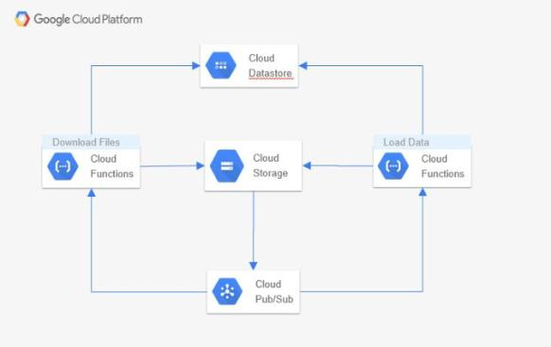

Figure 5.1

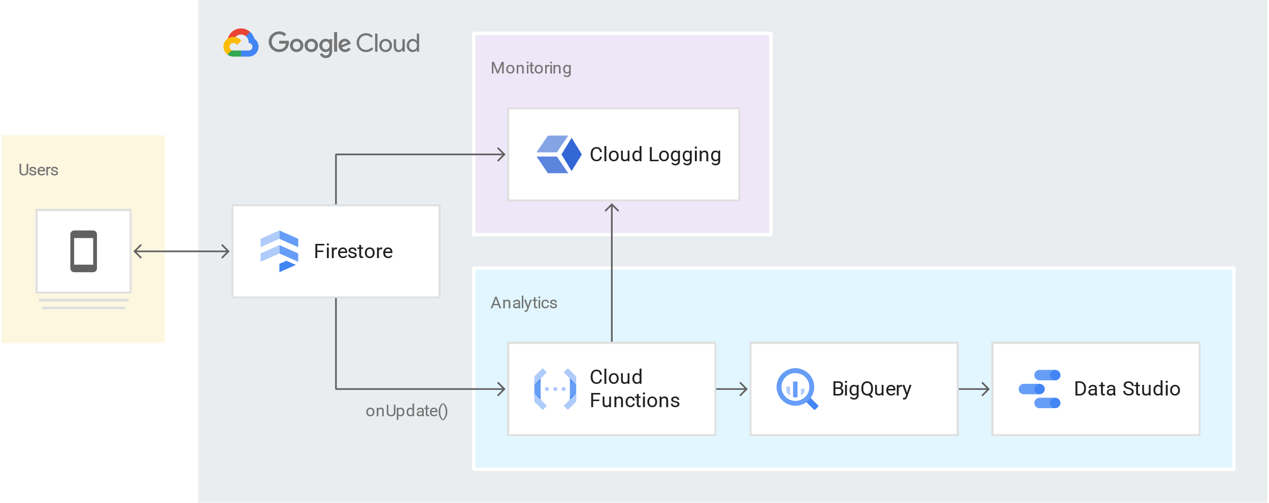

Figure 5.2

**CHAPTER 6**

**FEASBILITY STUDY**

**6.1 INTRODUCTION**

As the name implies, a feasibility analysis is used to determine the viability of an idea, such as ensuring a project is legally and Techinical feasibility as well as economically justifiable. It tells us whether a project is worth the investment—in some cases, a project may not be doable. There can be many reasons for this, including requiring too many resources, which not only prevents those resources from performing other tasks but also may cost more than an organization would earn back by taking on a project that isn’t profitable.Feasibility of the system in an important aspect, which is to be considered. The system needs to satisfy the law of economic, which states that the maximum output should be yielded in minimum available resources.

**Types of Feasibility Study:** A feasibility analysis evaluates the project’s potential for success; therefore, perceived objectivity is an essential factor in the credibility of the study for potential investors and lending institutions. There are four types of feasibility study—separate areas that a feasibility study examines, described below.

1. . Technical Feasibility

This assessment focuses on the technical resources available to the organization. It helps organizations determine whether the technical resources meet capacity and whether the technical team is capable of converting the ideas into working systems. Technical feasibility also involves the evaluation of the hardware, software, and other technical requirements of the proposed system. As an exaggerated example, an organization wouldn’t want to try to put Star Trek’s transporters in their building—currently, this project is not technically feasible.

2 Economic Feasibility

This assessment typically involves a cost/ benefits analysis of the project, helping organizations determine the viability, cost, and benefits associated with a project before financial resources are allocated. It also serves as an independent project assessment and enhances project credibility—helping decision-makers determine the positive economic benefits to the organization that the proposed project will provide.

3 Legal Feasibility

This assessment investigates whether any aspect of the proposed project conflicts with legal requirements like zoning laws, data protection acts or social media laws. Let’s say an organization wants to construct a new office building in a specific location. A feasibility study might reveal the organization’s ideal location isn’t zoned for that type of business. That organization has just saved considerable time and effort by learning that their project was not feasible right from the beginning.

1. Operational Feasibility

This assessment involves undertaking a study to analyze and determine whether—and how well—the organization’s needs can be met by completing the project. Operational feasibility studies also examine how a project plan satisfies the requirements identified in the requirements analysis phase of system development.

1. Scheduling Feasibility

This assessment is the most important for project success; after all, a project will fail if not completed on time. In scheduling feasibility, an organization estimates how much time the project will take to complete.

When these areas have all been examined, the feasibility analysis helps identify any constraints the proposed project may face, including:

* Internal Project Constraints: Technical, Technology, Budget, Resource, etc.
* Internal Corporate Constraints: Financial, Marketing, Export, etc.
* External Constraints: Logistics, Environment, Laws, and Regulations, etc

**6.2 MAIN ASPECTS**

* + 1. **ECONOMICAL FEASIBILITY**

System is economical feasible and can be easily implement with minimum hardware and software resources as this is a cloud based application platform is provided by cloud provider only there is a need of Internet connection in application. It is very important for designer to first analyze the system economically and determines that project is economical feasible or not. Costs and benefits of the proposed computer system must always be considered together, because they are interrelated and often interdependent. Although the systems analyst is trying to propose a system that fulfills various information requirements, decisions to continue with the proposed system will be based on a cost-benefit analysis, not on information requirements. In many ways, benefits are measured by costs, as becomes apparent in the next section.

With the development of mobile application, ultimately the number of customers of this android application will definitely increase.The total estimated cost for this application is nothing.The ultimate benefits from this mobile application will definitely exceeds the cost. This android “**Star application**” contain the AdMob which is economically benefical for this application .because these AdMob will generate the revenue.

### **Tangiable Costs :** The concepts of tangible and intangible costs present a conceptual parallel to the tangible and intangible benefits discussed already. Tangible costs are those that can be accurately projected by the systems analyst and the business’s accounting personnel.Included in tangible costs are the cost of equipment such as computers and terminals, the cost of resources, the cost of systems analysts’ time, the cost of programmers’ time, and other employeessalaries. These costs are usually well established or can be discovered quite easily, and are the costs that will require a cash outlay of the business.

**Intangible Costs** Intangible costs are difficult to estimate and may not be known. They include losing a competitive edge, losing the reputation for being first with an innovation or the leader in a field, declining company image due to increased customer dissatisfaction, and ineffective decision making due to untimely or inaccessible information. As you can imagine, it is next to impossible to project a dollar amount for intangible costs accurately. To aid decision makers who want to weigh the proposed system and all its implications, you must include intangible costs even though they are not quantifiable.

* + 1. **TECHNICAL FEASIBILITY**

For this application we get plan possibility high. For the present task , this application is produced for the Android OS . Be that as it may, it is examined thing that there are critical number of clients for others versatile stages additionally that is iOS The ideal impact of utilization will just show after it came to most extreme clients Functional requirements and non-functional requirements .

**Non Functional Necessity**

**•** Needs a mobile gadget

• The device should have Android OS

• The mobile gadget must have at least android version API level honeycomb.

• Mobile should be linked with either data connectivity or WIFI.

• The person should be well-known with the Android Phones Functional necessities:

• Android device should have proper internet connectivity.

• Individual have to download application either from the website or from Google PlayStore

**6.2.3: OPERATIONAL FEASIBILITY:**

1. It will be easy to read and use.

2. The customers can connect directly via the android application if they feel difficulty at any step.

3. A training video of how to use the application will also be provided to the users.

4. If a user does not want to read the Horoscope they can also listen the Horoscope (text to speech) .

5. The text to speech feature is provided in this application.

6. If the user want to share the Horoscope they can also share it.

7. After reading the Horoscope the user can also give their review(opnion) to it by the feedback(comment).

**6.3 BENEFITS**

Benefits of conducting a feasibility study:

* Improves project teams’ focus
* Identifies new opportunities
* Provides valuable information for a “go/no-go” decision
* Narrows the business alternatives
* Identifies a valid reason to undertake the project
* Enhances the success rate by evaluating multiple parameters
* Aids decision-making on the project
* Identifies reasons not to proceed

**CHAPTER 7**

**TESTING**

* 1. **INTRODUCTION**

Software Testing is a critical element of software quality assurance and represents the ultimate review of specification, design and code generation. The increasing visibility of software as a system element and the attendant “costs” associated with a software failure are motivating forces for well planned, thorough testing.

* + 1. **Testing Objectives**

The following are the testing objectives:

-Testing is a process of executing a program with the intent of finding an error.

-A good test case is one that has a high probability of finding an as-yet-undiscovered error .

-successful test is one that uncovers an as yet undiscovered error.

#### **Testing Principles**

The basic principles that guide software testing are as follows:

-All tests should be traceable to customer requirements.

-Tests should be planned long before testing begins.

-The parate principle applies to software testing.

* 1. **TYPE OF TESTING**
* **BLACK BOX TESTING**: -

The technique of testing without having any knowledge of the interior workings of the application is called Blackbox testing. The tester is oblivious to the system architecture and does not have access to the source code. Typically, while performing a Blackbox test, a tester will interact with the system's user interface by providing inputs and examining outputs without knowing how and where the inputs are worked upon.

* **WHITE BOX TESTING: -**

White­box testing is the detailed investigation of internal logic and structure of the code. White­box testing is also called glass testing or open box testing. In order to perform Whitebox testing on an application, a tester needs to know the internal workings of the code.

* **GREY BOX TESTING**: -

Grey box testing is a technique to test the application with having a limited knowledge of the internal workings of an application. In software testing, the phrase the more you know, the better carries a lot of weight while testing an application.

* **UNIT TESTING: -**

Unit Testing contains the testing of each unit of Recruitment Application. We have tested each interface by input values and check whether it is working properly working or not we also tested database connectivity. We have entered value in interface and check that the values are properly goes to corresponding tuples or not.

* **INTEGRATION TESTING: -**

Integration testing is defined as the testing of combined parts of an application to determine if they function correctly. Integration testing can be done in two ways: Bottom up integration testing and Top down integration testing.

* **SYSTEM TESTING**: -

System testing tests the system as a whole. Once all the components are integrated, the application as a whole is tested rigorously to see that it meets the specified Quality Standards. This type of testing is performed by a specialized testing team.

* **ACCEPTANCE TESTING: -**

This is arguably the most important type of testing, as it is conducted by the Quality Assurance Team who will gauge whether the application meets the intended specifications and satisfies the client’s requirement. The QA team will have a set of pre­written scenarios and test cases that will be used to test the application. In System Testing we have tested entire Recruitment Application. We have run all programs as a single system and inputs various test cases and analyse that all are going correctly or not. In system testing we have tested various test cases. According to which, Application showed the corresponding error message.

**7.3 LEVEL OF TESTING**

There are different levels of testing

->Unit Testing

->Integration Testing

->System Testing

**7.3.1 Unit testing:** Unit testing focuses verification effort on the smallest unit of

software design, the module. The important control parts are tested to uncover with in the boundary of the module. The module interface is tested to ensure that the information properly flows into and out of the program unit and boundary conditions are tested to ensure that the modules operate properly at boundaries established to limit or restrict processing. Test date is provided through testing screens.

**7.3.2 Integration testing:**  Integrating testing is a systematic technique for constructing Program structure while conducting tests to uncover error associates with interfacing .The objective is to take unit modules and built a program structure that has been directed by design.

• Integration Testing will test whether the modules work well together.

• This will check whether the design is correct.

• Integration can be done in 4 different ways:

**7.3.3 System testing:**  System testing is the process of testing the completed software as a part of the environment it was created for. It is done to ensure that all the requirements specified by the customer are met. System testing involves functional testing and performance testing.

* + System Testing will contain the following testing :
  + Functional Testing
  + Performance Testing
  1. **SOME IMPORTANT OBSERVATIONS**

**7.4.1 Testing Test Scenarios**

1.Check if the page load time is within the acceptable range.

2.Check the page load on slow connections.

3.Check the response time for any action under a lighr, normal , moderate, and heavy load conditions.

4.Check the performance of database store procedure and triggers.

5.Check for load testing of the application.

6.Check the database execution time.

7.Check for the stress testing of the application.

**7.4.2 TEST CASE RESULT**

Testcase# Description Result

TC#1 Loading Data Passed

TC#2 Connection Passed

TC#3 Content Passed

TC#4 First Display Passed

TC#5 Second Display Passed

TC#6 Third Display Passed

TC#7 Notification Passed

**CHAPTER 8**

**CONCLUSION AND FUTURE SCOPE**

**8.1 CONCLUSION**

The package was designed in such a way that future modifications can be done easily. Automation of the entire system improves the efficiency. It provides a friendly graphical user interface which proves to be better when compared to the existing system.

It gives appropriate access to the authorized users depending on their permissions.

A software project means a lot of experience. We learned a lot through this project. This project has sharpened our concept game engine, animation, and the software-hardware interface. We learned a lot about different documentation. Now I have much wider knowledge of the features Java offers and put into practice various object-oriented methods that learnt last semester.

**8.2 FUTURE SCOPE**

The mobile application market is growing faster than a beanstalk. The industry is huge and growing daily, and there is no end in sight. Expectedly, the mobile developer population has boomed, and the number of mobile apps in the market has hit new heights.

The revenue generated by the global mobile app industry has skyrocketed. Hybrid monetization models, such as in-app ads and in-app purchases, are quickly gaining popularity in the business world.

Most studies show that in-app advertising is set to be a key driver of mobile growth over the coming years (see Statista’s, IHS Markit’s and Forbes’s report.

**REFERENCES**

[1] da Silva Junior, L. L. N., Kohwalter, T. C., de Carvalho, A. P., & Murta, L. G. P. (2021). Sequential coding patterns: How to use them effectively in code recommendation. Information and Software Technology, 106690.

[2] Liu, S., Guo, Z., Li, Y., Lu, H., Chen, L., Xu, L., ... & Xu, B. (2021). Prioritizing code documentation effort: Can we do it simpler but better?. Information and Software Technology, 106686.

[3] Vogel, T., Tran, C., & Grunske, L. (2021). A comprehensive empirical evaluation of generating test suites for mobile applications with diversity. Information and Software Technology, 130, 106436.

[4] Li, Z., Jiang, Z., Chen, X., Cao, K., & Gu, Q. (2021). Laprob: A Label propagation-Based software bug localization method. Information and Software Technology, 130, 106410.

[5] García-Valls, M., Dubey, A., & Botti, V. (2018). Introducing the new paradigm of social dispersed computing: Applications, technologies and challenges. Journal of Systems Architecture, 91, 83-102.

[6] Yang, T., Deng, Q., & Sun, L. (2019). Building real-time parallel task systems on multi-cores: A hierarchical scheduling approach. Journal of Systems Architecture, 92, 1-11.

[7] McClean, K., Greer, D., & Jurek-Loughry, A. (2020). Social network analysis of open source software: A review and categorisation. Information and Software Technology, 106442.

[8] Echeverría, J., Pérez, F., Panach, J. I., & Cetina, C. (2021). An empirical study of performance using Clone & Own and Software Product Lines in an industrial context. Information and Software Technology, 130, 106444.

[9] Van Antwerp, M. (2010). Evolution of Open Source Software Networks. In OSS 2010 Doctoral Consortium, Collocated with the 6th International Conference on Open Source Systems, OSS 2010 (pp. 25-39).

[10] Garg, S., & Baliyan, N. (2021). Comparative analysis of Android and iOS from security viewpoint. Computer Science Review, 40, 100372.

[11] Steven Salerno, Ameya Sanzgiri , Shambhu Upadhyaya . Exploration of Attacks on Current Generation Smartphones . Procedia Computer Science , 2011 , Pages 546-553

12] Jason K. MacDuffie , Patricia A. Morreale . Comparing Android App Permissions . DUXU 2016 , pp57-64

[13] Kumar, R., & Goyal, R. (2019). On cloud security requirements, threats, vulnerabilities and countermeasures: A survey. Computer Science Review, 33, 1-48.

[14] Ohyver, M., Moniaga, J. V., Sungkawa, I., Subagyo, B. E., & Chandra, I. A. (2019). The comparison firebase realtime database and MySQL database performance using wilcoxon signed-rank test. Procedia Computer Science, 157, 396-405.

[15] Albertengo, G., Debele, F. G., Hassan, W., & Stramandino, D. (2020). On the performance of web services, google cloud messaging and firebase cloud messaging. Digital Communications and Networks, 6(1), 31-37.